Newsletter
Autumn 2018

Message from the Chair
(Sue Llewellyn)

2017/18 was an exceptionally busy year for the ODA seeing unprecedented interest in our Saturday School programme. Seventy-five pupils received support during the year. The ODA also received and responded to in excess of 600 enquires from people in Oxfordshire wanting advice about dyslexia. And without doubt, the ODA ran one of its most successful conferences ever with over 200 participants benefiting from insights offered by our speakers on dyslexia research, support and their experiences.
We, the ODA, are only too aware that all these initiatives in 2017/18 were made possible through the dedication of its teachers, the voluntary help of its trustees and members’ support. This newsletter reaches out to celebrate our achievements in 2017/18 and ask that you continue to support us as we look forward to similar successes in 2018/19.

Alice’s story
Many of you will remember visiting Alice Preston’s stand at the ODA Conference and the mention of her work by Professor Stein in his presentation.

Lorraine Collett, one of the ODA Trustees met with Alice before her graduation from Oxford Brookes University in 2017. Here is their interview.

Do dyslexia and the written word go together? Often, we hear about their difficult connection, but it is not quite the story that Alice Preston, First Class Honours graduate from Oxford Brookes University (2017), wants to tell. I had the pleasure of walking and talking with Alice at the Brookes’ Third Year Fine Art Exhibition in May.

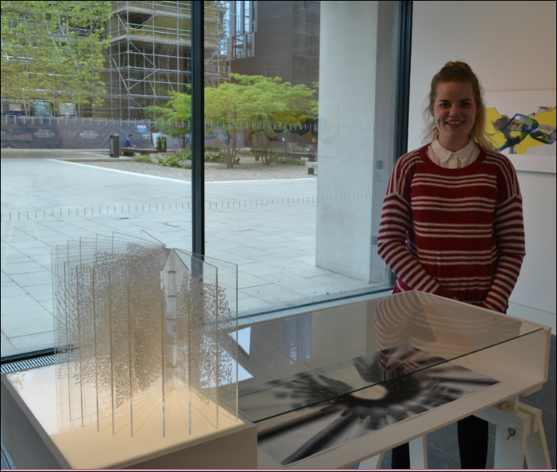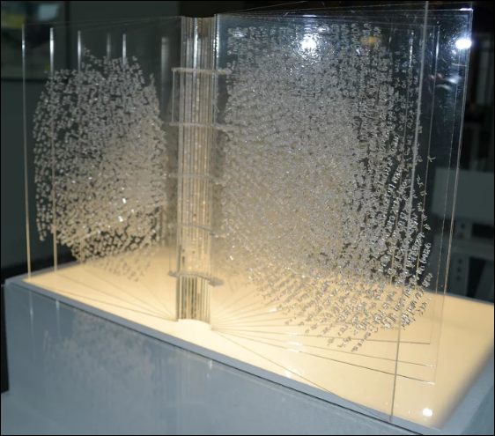

Pointing towards one of her creations, she said, “This book is my story.” With what she described as a “fire in my belly,” she declared, “I’m proving to everyone that I can go out and do it, and this is my way of doing it.”

Alice’s book, glistening under the carefully staged lighting, was there waiting to be read. Using correspondence from a family member written over the duration of the three years of her degree course, Alice had an idea for her final year project. What if she could use the words from these letters!

Carefully copying the words in a dyslexia-friendly font which she learnt about while at university, she wrote on prints of the lines of the palm of her hands. Seeing the amazing effect this had and how it explained, Alice, the artist, she decided to replicate the process on to Perspex pages.

She considers her art is a form of palmistry which not only extends the interpretation of a person's character by examining the palm of their hand but also that of the author of the words. One entry from her grandfather reads “Are you eating properly at university?”

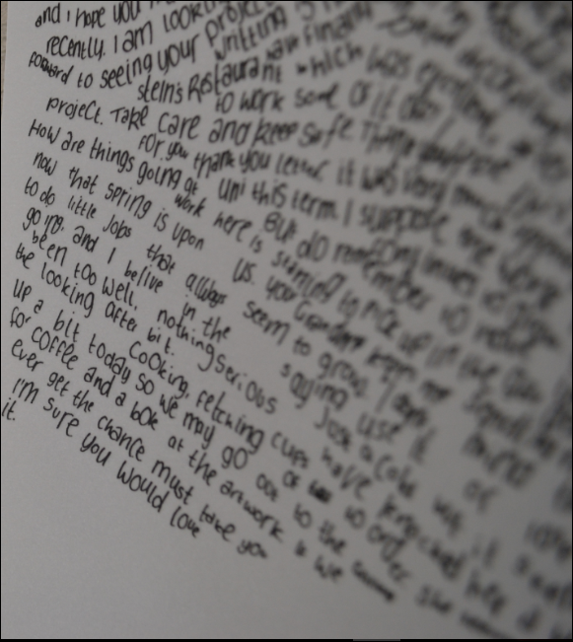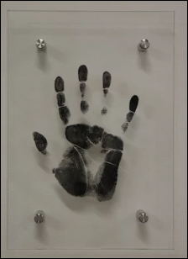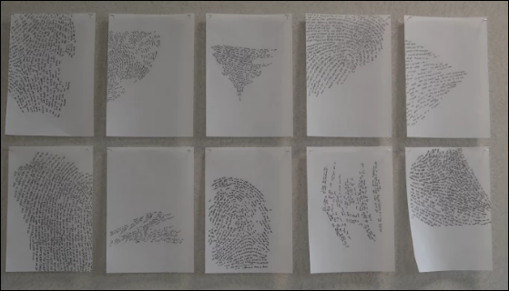

Alice talks about her identity being in the text and the journey that she has taken in understanding her own story. “Three years ago I was very different and I looked at art in a very different way, and I wouldn’t have made this; I wouldn’t have even thought of this.”

Perhaps similar to many children growing up with dyslexia, Alice isn’t without memories about the struggles she’d had and how she wanted to be good at reading and writing. But she says, “I just didn’t know how I could get better.” Then she found art, or did it find her? Subsequently, art became the activity she found herself doing at lunchtimes and she would receive praise for it. With a beaming smile she recalled that it gave her, “a sense of relief because everything was an experiment and free.”

She doesn’t lament about her later diagnosis of dyslexia, which happened when she came to university, but instead feels, “it helped things to make more sense” and helped her to understand herself better: “why I switched off in class - I now know I have and use a difference in thought processing”. This became the subject of her dissertation and she explored how artists’ creativity and thinking is enhanced by dyslexia. It is interesting that Angela Fawcett, in the recent edition of Dyslexia Contact, Access the Word, Access the World (2017) concurs, “Indeed, our most recent theory suggests that strengths in dyslexia may even be related to slowness in adaptation that allows a more creative and flexible turn of thought.” Is Alice, the artist, a product of her own dyslexia?

Alice describes herself as a “list person” – a strategy she needs to use to manage her days. After all, she has to work to exhibition deadlines, arrange private viewings, select pieces of work to show from her vast collections​ and so on. And as a student she has needed to navigate reading lists, library resources and journals and write essays to coursework deadlines. She’s managed it all.
“Whether or not your brain works differently if you are dyslexic, you can shine with the appropriate support” (ibid, 2017).

It will probably be of no surprise to readers that the theme of the written word runs through Alice’s art collection and no doubt will continue to do so as she grows and develops as an artist.

So, what has Alice been up to this year? She’s already completed a year of her Masters in Illustration and Book Arts.

Andrew’s story
You can change the look of linked text boxes by using color, shading, borders, and other formatting. Select the text box you want to format and then double click its border to open the Format Text Box dialog box. If you want to change the color or borders on a text box, choose the Colors and Lines tab. To change the size, scale, or rotation, click the Size tab. To change the position of the text box on the page, click the Position Tab. If you have other text surrounding the text box, and want to change the way the text wraps around it, click the Wrapping tab. If you want to format all the text boxes in an article, you must format them individually - the formatting on one text box will not apply to the others in the sequence.
Using Linked Text for Parallel Articles
You can use linked text boxes to flow text in parallel “columns” from page to page. This method gives different results than using the Column command on the Format menu, which causes text in column 1 to flow or “snake” to column 2 on the same page. By using linked text boxes, you can instead have text from column 1 flow to column 1 on the next page. The text beside it in column 2 can flow to column 2 on the next page, parallel to column 1. This technique is useful if you need to group two similar articles, for instance, an article translated in English on the left and the same article translated in French on the right.
To flow text in parallel, display paragraph marks in your document. Click at the top of the page where you want the side-by-side columns to start, and press Enter twice. Click in the first paragraph mark on the page. On the Insert menu, click Text Box and drag on the page where you want the first column. Click Text Box again and then click and drag where you want the second column. Click in the last paragraph mark on the page, and press Ctrl + Enter to create a page break.
Repeat the process for each page that will contain side-by-side columns in your document and then return to the first text box you created. Click the text box on the left once to select it. Click your right mouse button and then click Create Text Box Link. The pointer becomes a pitcher. Click the text box on the left side of the second page to create a link. Create links for all text boxes within the same article on the left side of the document. Repeat the process for every text box in the right chain or article.
Pressing Enter twice at the top of each page will create an extra empty paragraph. This blank paragraph is useful if you want to insert text or graphics outside of the text boxes. You can delete the extra blank paragraph if you don't need it.
Janet’s book
You can copy an article or a chain of text boxes that are linked together, to another document or to another location in the same document. To copy linked text boxes and the text they contain, you must copy all the linked text boxes in an article. Select the first text box in an article. Hold down Shift, and click each additional text boxes you want to copy. On the Edit menu, click Copy. Click where you want to copy the text boxes and then click Paste.
To copy some of the text from an article, select the text you want to copy from the article and then copy it. Do not select the text box. You can paste text you’ve copied directly into your document, into another location within the same article, or into another article.
Post Conference

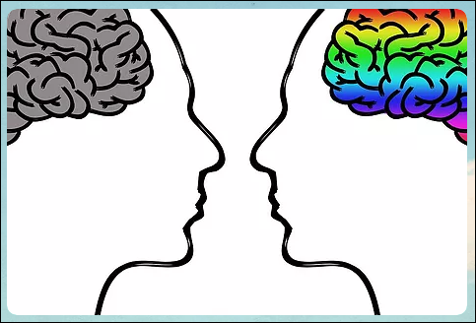
ODA Conference
14 October 2018
Access to further information
Professor John Stein’s talk on Wobbles, Warbles and Fish - The Neural Basis of Dyslexia
Follow this link to revisit Prof Stein’s talk:
https://docs.wixstatic.com/ugd/ca1d4c_8c8e3d8d1e434ee3853f5baeed366aae.pdf

Sean Douglas’ talk - Me & My Mate Dyslexia
Follow this link to Sean’s website, the Codpast and his many podcasts
https://thecodpast.org/

See Pages 2 and 3 for further information from the ODA Conference contributors.

Wow – what a turnout on a Saturday morning and how good to see so many people interested in dyslexia!
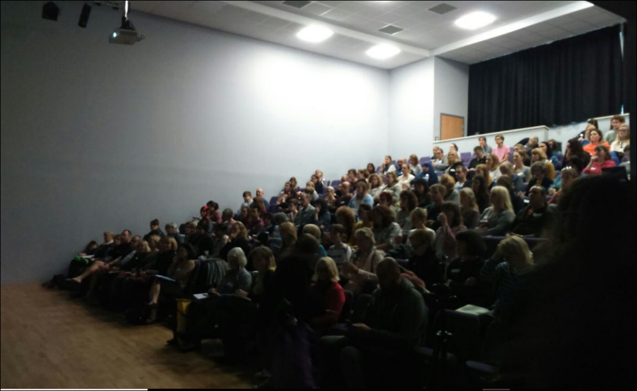

Inside This Issue
1 | Message from the Chair, Sue Llewellyn
1 | Post Conference information
2/3 | Stories and News
3 | Assistive Technology (AT)
4 | Extended message from the Chair
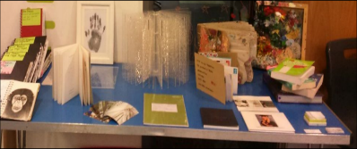

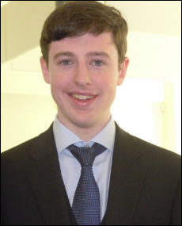

Andrew’s story
Andrew Francis has joined the ODA team as our web editor. Andrew says,
“In June 2017 I graduated from Oxford Brookes University with a 2:1 in Computer Science. At University I was the Quiz Society President and a member of the Dance, and Computing Societies.
Then I enjoyed a summer internship with the SOCIAM - a project at Oxford University’s Computing Science Department. Currently I am working as a Financial Systems Service Desk Analyst at Oxford University.”

A warm welcome to Andrew and we are looking forward to the improvements you can make to the ODA website.

We would like to give special mention to Andrew XXXX who has taken on the role of looking after our ODA website. Andrew, also a graduate of Oxford Brookes University in 2017, gradated in XXXXX and is now XXXXXXX
Studying with Dyslexia
It’s OK to do things differently

ISBN 978-1-352-00039-9
Palgrave Macmillan Education 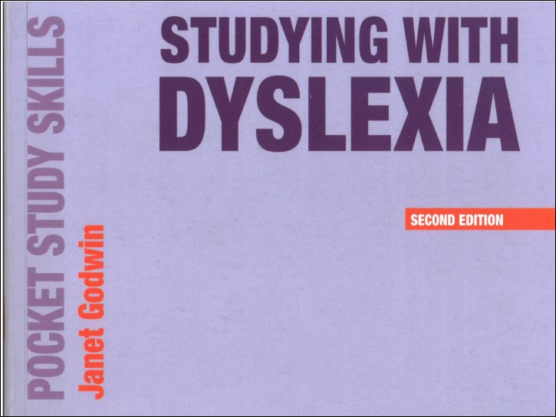

This guide is split into three parts and explains dyslexia/specific learning difficulties (SpLD) and why working with and not against an SpLD puts “YOU in charge of [it] and not the other way around’ (2017:x). Suggesting this is a book to dip into rather than read from cover to cover, Godwin offers ideas for effective study. Though aimed at students in college or in higher education, school pupils would find relevance from the easy to dip into resource as well. Readers will identify with the characteristics Godwin identifies and be appreciative of the practical and straight forward ideas she offers.

An invaluable resource for those who are dyslexic or for those who want to know more about supporting someone who has dyslexia.

AT Exhibitors at the ODA Conference
See their websites for trial versions of their products.

An excellent resource

http://dyslex.io/

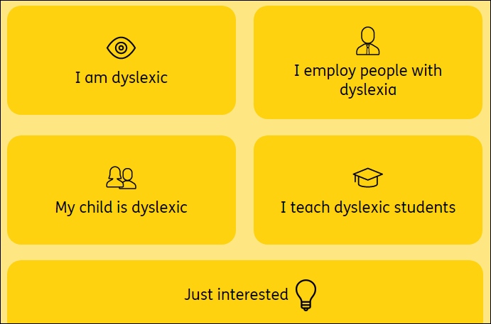

ODA Chair’s Review

What a very busy year 2017 to 2018 has been!

I would very much like to extend my thanks to all the trustees for their continual support. For some time now, we have been a relatively small team and we’ve achieved a great deal. We are delighted to welcome two new members: Andrew Francis and Dom Stern who will bring further expertise to the team including an extensive knowledge of IT.

Becoming a Committee Member – new roles

But, we are still in need of two more committee members. Why? If we are going to be able to continue and do the necessary fundraising required to sustain our work, we need more help. We need a dedicated fundraiser and a Membership Secretary. The ODA pays to rent rooms for our Saturday School, and although the amount we pay is discounted, over time the discount is reduced and for 2018/19 the cost is £5,000 per annum.

Fundraising Initiatives

2017/18
To cover the cost of the rent, we launched a fundraising campaign managed by our treasurer, Glyn Pritchard. We were successful in securing donations from the following:

PF Charitable Trust | £ 500
Stanton Ballard Charitable Trust | £2,000
Robert & Margaret Moss Charitable Trust | £1,000
JA Pye Charitable Trust | £ 500
Doris Field Charitable Trust | £1,000
St Michael & All Saints Charities | £5,000
Ernest Cook Charitable Trust | £2,500

Dyslexia Conference, October 2018

In addition to our fundraising achievements, a key event this year has been the very successful Dyslexia Conference, which we held on the 14th October at Oxford Spires Academy. Over 200 people attended and the feedback has been wonderful – so much so, we would love to run another conference in the not too distant future, but it is contingent on having more committee members. The conference opened with an insightful and informative presentation from our President, Prof John Stein, and his fascinating presentation on Wobbles, Warbles & Fish’ - the Magnocellular Theory of Dyslexia. Inspirational talks followed from Sean Douglas creator of The Codpast and local advisers who gave practical help on how to secure support at school.

Increase in Enquiries for Advice and Support

There has been a significant increase in the number of enquiries from adults on our Helpline and by email requesting guidance regarding dyslexia in the workplace, and how to secure dyslexia support while studying on further education courses. We have updated our website with guidance for adults. Looking forward, we hope to offer tutorials for adults with dyslexia as this is frequently requested. We have begun to help financially with adult assessments and have an arrangement with a local assessor. This is an area that would benefit from more attention dependent on committee capacity.

Saturday School

Our main area of support is the Saturday School, which has been running for over 20 years. Numbers and requests for places continue to rise. We currently work with over 70 students on Saturday mornings during term time. Our Helpline continues to receive calls from parents who seek advice on both assessments and tuition.

Communication
I would like to conclude with a further plea for more committee members so please do contact us if you would like to get involved. Dom has been instrumental in setting up a way for those who cannot be present at our meetings to join in electronically so there is not always the need to attend the physical meetings.

Sue Llewellyn

